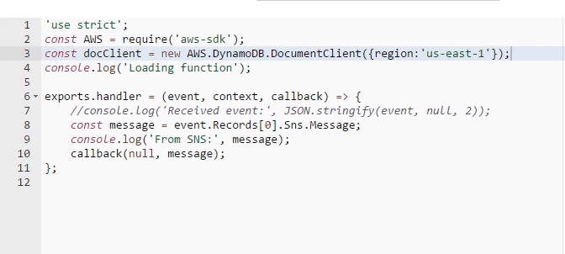\

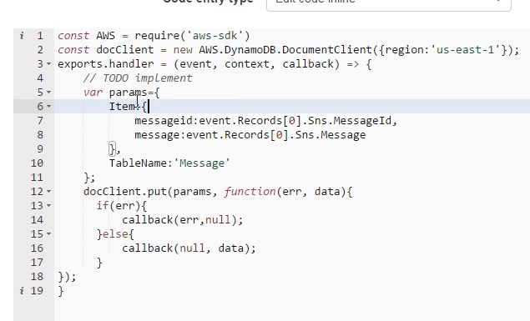

Using the [Lambda console](https://console.aws.amazon.com/lambda) create the following Lambda function and name it messageStore:

console.log('Loading event');

var aws = require('aws-sdk');

var ddb = new aws.DynamoDB({params: {TableName: 'snslambda'}});

exports.handler = function(event, context) {

var SnsMessageId = event.Records[0].Sns.MessageId;

var SnsPublishTime = event.Records[0].Sns.Timestamp;

var SnsTopicArn = event.Records[0].Sns.TopicArn;

var LambdaReceiveTime = new Date().toString();

var itemParams = {Item: {SnsTopicArn: {S: SnsTopicArn},

SnsPublishTime: {S: SnsPublishTime}, SnsMessageId: {S: SnsMessageId},

LambdaReceiveTime: {S: LambdaReceiveTime}  }};

ddb.putItem(itemParams, function() {

context.done(null,'');

});

};

This Lambda function takes the SNS message it receives (see below for the exact SNS message structure) and extracts the MessageId, Timestamp, and TopicArn. It then stores this data into the DynamoDB table that we created prior to this step. Additionally, it stores the current time from the Lambda function’s perspective.

To use SSM from a Lambda function, you also need to add a policy to your IAM lambda_exec_role